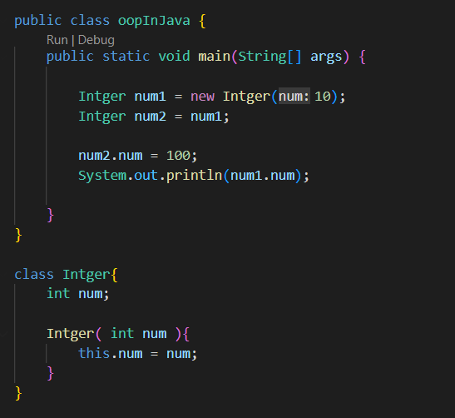

Here both num1 num2 are pinting to the same object in the heap

So changing the num2 will also reflect the changes in num1

But

**We cannot do similar in Strings, becoz strings are immutable in java**

**Also we canot do similar in wrapper classes objects, becoz of final keyword**

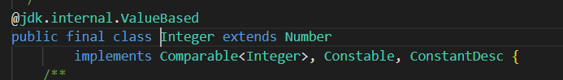

What is final keyword ?

Just like the name, final means final

A final value

So it cannot be changed

Becoz if the value changed than that value won’t be final value

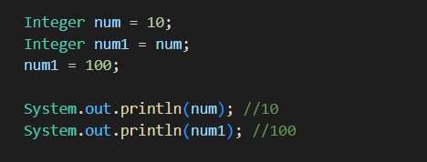

looking closely here num1 and num are pointing to same object

So changing num1 should have changed the num also normally

But since wrapper classes are defined using final keyword, we cannot change the objects made by wrapper classes

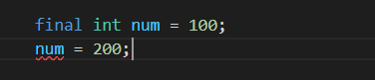

This is not allowed

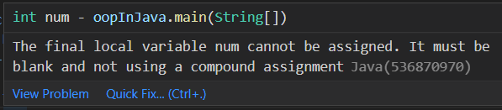

**More about final**

It is seems like const in java script

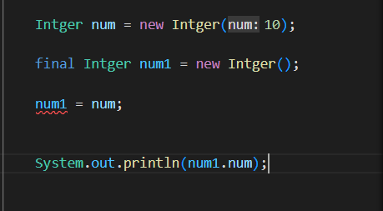

here num1 is a reference variable to an empty object

But this is a final reference variable, meaning this is lika a constant reference

The reference cannot be changed

The originally initialized reference is the final reference, and java won’t allow reinitialization

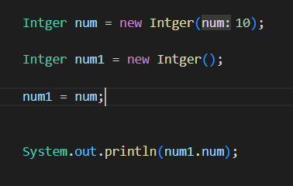

But without final keyword we won’t have any problem



But

Here only the reference is constant, we can still change the values inside the object, it is not saying those are constant, only the name which is reference is the final value or constant or immutable

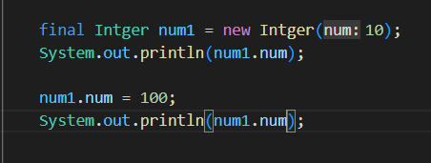

We can still change the data values inside the object